equ

I CAN:

Pair like cards together

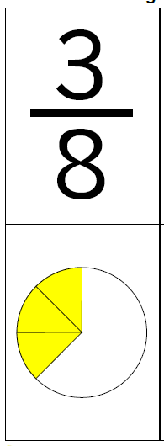

**I CAN:**

Write a fraction

C:\Users\Carlos\AppData\Local\Microsoft\Windows\Temporary Internet Files\Content.IE5\BBGGV7O2\MC900410605[1].wmf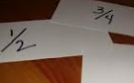

**I CAN:**

Draw a fraction

C:\Users\Carlos\AppData\Local\Microsoft\Windows\Temporary Internet Files\Content.IE5\BBGGV7O2\MC900410605[1].wmf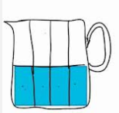

**I CAN:**

**Say the name of a fraction out loud**

**1/3 is “ONE THIRD”**C:\Users\Carlos\AppData\Local\Microsoft\Windows\Temporary Internet Files\Content.IE5\BBGGV7O2\MC900304349[1].wmf

One Third

**I CAN:**

**Match different representations of a fraction**

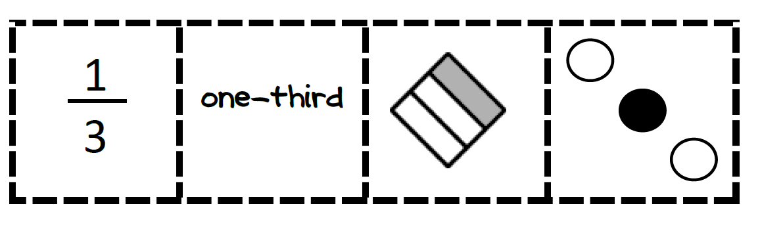

I