equ

**I CAN:**

**Color in the fraction for the pizzas.**

.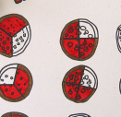C:\Users\Carlos\AppData\Local\Microsoft\Windows\Temporary Internet Files\Content.IE5\FTI72H2M\MC900013073[1].wmf

**I CAN:**

**Separate golden blocks equally.**

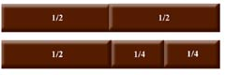

I can:

Use the unifix cubes to help me see fraction.

Draw in the rectangles to help me see fractions. 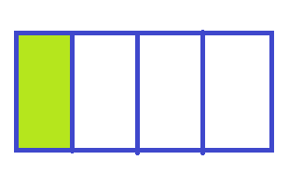

I CAN:

Choose a denominator and numerator. 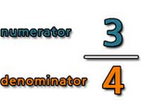

The larger number will be the denominator.

I CAN:

Pair like cards together

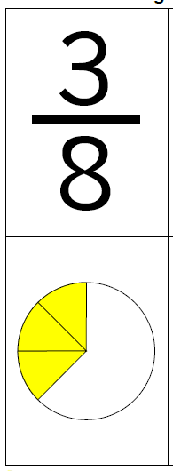

**I CAN:**

**Compare fractions**

**14**

**1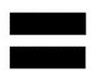1**

**I CAN:**

Write a fraction

C:\Users\Carlos\AppData\Local\Microsoft\Windows\Temporary Internet Files\Content.IE5\BBGGV7O2\MC900410605[1].wmf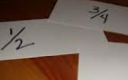

**I CAN:**

Draw a fraction

C:\Users\Carlos\AppData\Local\Microsoft\Windows\Temporary Internet Files\Content.IE5\BBGGV7O2\MC900410605[1].wmf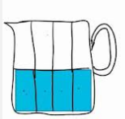

**I CAN:**

**Say a fraction out loud**

**1/3 is “ONE THIRD”**C:\Users\Carlos\AppData\Local\Microsoft\Windows\Temporary Internet Files\Content.IE5\BBGGV7O2\MC900304349[1].wmf

One Third

**I CAN:**

**Match different representations of a fraction**

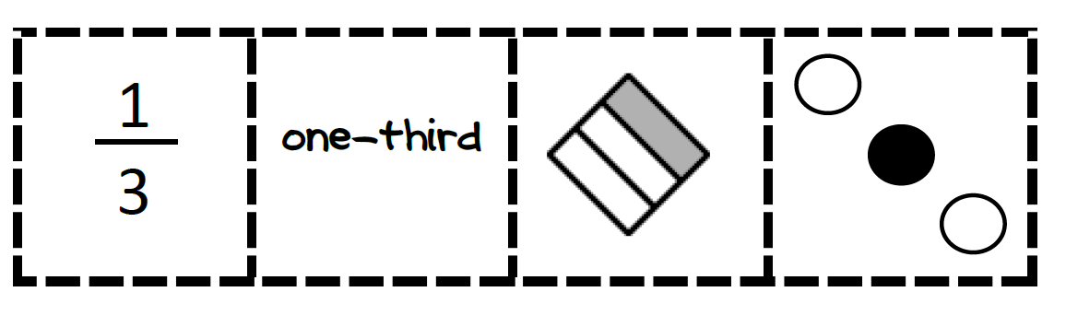

I