“_____is equal to______”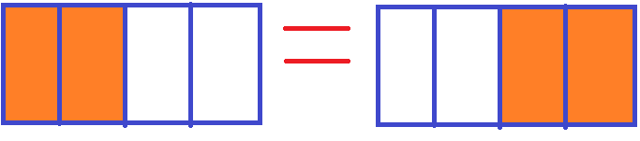

“____ is less than ______”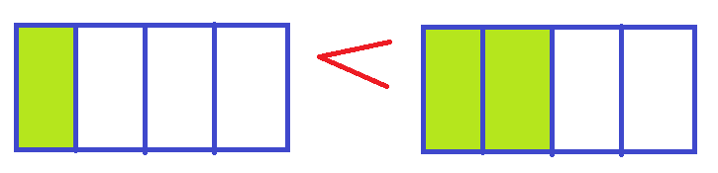

“_____is more than _______”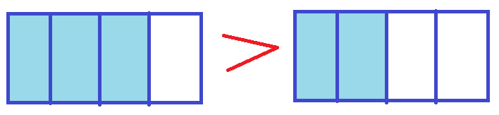

* Fraction bar 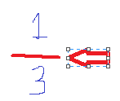
* Numerator 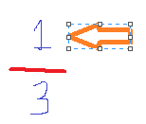 (names part of the whole) 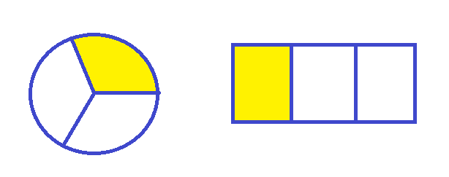
* Denominator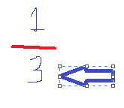 (names the whole) 

Ex: “ 2 of ½ makes 1 set”

“______ of _____ makes 1 set”

“ Both of us have the same number of sets, you have ____ of ____ and I have _____ of ______”

“ My numerator is ______ and my denominator is ______, so my fraction is _______.”

“Do you have ______ ?”

“_____ is greater than______, so I will use (symbol =, <, or >).”

“_____is less than______, so I will use (symbol =, <, or >).”

“_____ is equal to _____, so I will use (symbol =, <, or >).”

“_______ is smaller, so it will be the numerator.”

“_____ is larger, so it will be the denominator.”

“My fraction is ________”