Ex: “ 2 of ½ makes 1 set”

“______ of _____ makes 1 set”

“ Both of us have the same number of sets, you have ____ of ____ and I have _____ of ______”

* Fraction bar 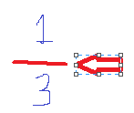
* Numerator 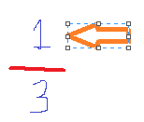 (names part of the whole) 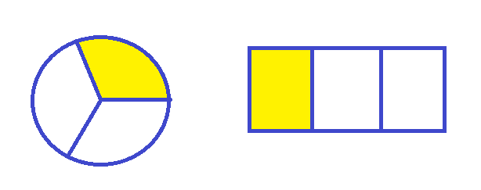
* Denominator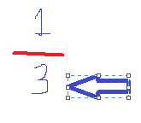 (names the whole) 