* Fraction bar 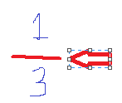
* Numerator 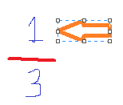 (names part of the whole) 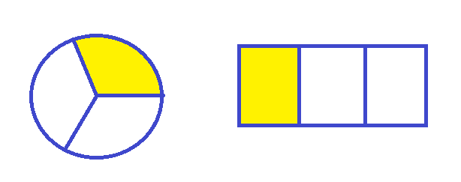
* Denominator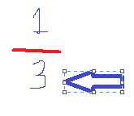 (names the whole) 

“ My numerator is ______ and my denominator is ______, so my fraction is _______.”

“Do you have ______ ?”

“_______ is smaller, so it will be the numerator.”

“_____ is larger, so it will be the denominator.”

“My fraction is ________”